**LAPORAN TUGAS TEKNIK PEMROGRAMAN**

Membuat Aplikasi Penjualan



**Disusun Oleh :**

Nama : Ujang Wahyu(151524031)

Kelas : 1A- D4 Teknik Informatika

**Jurusan Teknik Komputer dan Informatika**

**Program Studi D4 Teknik Informatika**

**Politeknik Negeri Bandung**

**2016**

**SOURCE CODE**

package aplikasipenjualan;

import javax.swing.JOptionPane;

/**

*

* @author Ujang Wahyu

*/

public class Main extends javax.swing.JFrame {

public double total = 0;

/**

* Creates new form Main

*/

public Main() {

initComponents();

}

private void cb_steakActionPerformed(java.awt.event.ActionEvent evt) {

// TODO add your handling code here:

if(cb_steak.isSelected()){

textEditTrue();

total += 50000;

}else{

total-= 50000;

textEditFalse();

}

totalBayar.setText(String.valueOf(total));

}

private void totalBayarActionPerformed(java.awt.event.ActionEvent evt) {

// TODO add your handling code here:

}

private void cb_spagethiActionPerformed(java.awt.event.ActionEvent evt) {

// TODO add your handling code here:

if(cb_spagethi.isSelected()){

textEditTrue();

total += 40000;

}else{

total -=40000;

textEditFalse();

}

totalBayar.setText(String.valueOf(total));

}

private void cb_pizzaActionPerformed(java.awt.event.ActionEvent evt) {

// TODO add your handling code here:

if(cb_pizza.isSelected()){

textEditTrue();

total += 80000;

}else{

textEditFalse();

total -= 80000;

}

totalBayar.setText(String.valueOf(total));

}

private void B_simpanActionPerformed(java.awt.event.ActionEvent evt) {

// TODO add your handling code here:

if(txtNama.getText().length()==0){

JOptionPane.showMessageDialog(this,"Nama belum di isi harap di isi!");

txtNama.requestFocus();

}

if(txtAlamat.getText().length()==0){

JOptionPane.showMessageDialog(this,"Alamat belum di isi harap di isi!");

txtAlamat.requestFocus();

}

if(txtPhone.getText().length()==0){

JOptionPane.showMessageDialog(this,"Phone belum di isi harap di isi!");

txtPhone.requestFocus();

}

if(total == 0){

JOptionPane.showMessageDialog(this,"Anda belum memilih menu makanan");

}else{

txtArea_Hasil.append("\nNama : "+txtNama.getText() +

"\nAlamat : "+txtAlamat.getText()+

"\nPhone : "+txtPhone.getText()+

"\nPesanan :");

if(cb_steak.isSelected()){

txtArea_Hasil.append("\n - Steak");

}

if(cb_spagethi.isSelected()){

txtArea_Hasil.append("\n - Spagethi");

}

if(cb_pizza.isSelected()){

txtArea_Hasil.append("\n - Pizza");

}

txtArea_Hasil.append("\nTotal Pembayaran :"+ String.valueOf(total));

}

}

private void refreshActionPerformed(java.awt.event.ActionEvent evt) {

// TODO add your handling code here:

txtNama.setText("");

txtAlamat.setText("");

txtPhone.setText("");

}

private void txtNamaActionPerformed(java.awt.event.ActionEvent evt) {

// TODO add your handling code here:

}

/**

* @param args the command line arguments

*/

public static void main(String args[]) {

/* Set the Nimbus look and feel */

//<editor-fold defaultstate="collapsed" desc=" Look and feel setting code (optional) ">

/* If Nimbus (introduced in Java SE 6) is not available, stay with the default look and feel.

* For details see http://download.oracle.com/javase/tutorial/uiswing/lookandfeel/plaf.html

*/

try {

for (javax.swing.UIManager.LookAndFeelInfo info : javax.swing.UIManager.getInstalledLookAndFeels()) {

if ("Nimbus".equals(info.getName())) {

javax.swing.UIManager.setLookAndFeel(info.getClassName());

break;

}

}

} catch (ClassNotFoundException ex) {

java.util.logging.Logger.getLogger(Main.class.getName()).log(java.util.logging.Level.SEVERE, null, ex);

} catch (InstantiationException ex) {

java.util.logging.Logger.getLogger(Main.class.getName()).log(java.util.logging.Level.SEVERE, null, ex);

} catch (IllegalAccessException ex) {

java.util.logging.Logger.getLogger(Main.class.getName()).log(java.util.logging.Level.SEVERE, null, ex);

} catch (javax.swing.UnsupportedLookAndFeelException ex) {

java.util.logging.Logger.getLogger(Main.class.getName()).log(java.util.logging.Level.SEVERE, null, ex);

}

//</editor-fold>

/* Create and display the form */

java.awt.EventQueue.invokeLater(new Runnable() {

public void run() {

new Main().setVisible(true);

}

});

}

private void textEditFalse() {

txtNama.setEnabled(false);

txtAlamat.setEnabled(false);

txtPhone.setEnabled(false);

B_simpan.setVisible(false);

txtNama.setText("");

txtAlamat.setText("");

txtPhone.setText("");

}

private void textEditTrue() {

txtNama.setEnabled(true);

txtAlamat.setEnabled(true);

txtPhone.setEnabled(true);

B_simpan.setVisible(true);

}

// Variables declaration - do not modify

private javax.swing.JButton B_simpan;

private javax.swing.JCheckBox cb_pizza;

private javax.swing.JCheckBox cb_spagethi;

private javax.swing.JCheckBox cb_steak;

private javax.swing.JLabel jLabel1;

private javax.swing.JLabel jLabel2;

private javax.swing.JLabel jLabel3;

private javax.swing.JLabel jLabel4;

private javax.swing.JLabel jLabel5;

private javax.swing.JLabel jLabel6;

private javax.swing.JLabel jLabel7;

private javax.swing.JLabel jLabel8;

private javax.swing.JPanel jPanel1;

private javax.swing.JPanel jPanel2;

private javax.swing.JPanel jPanel3;

private javax.swing.JScrollPane jScrollPane1;

private javax.swing.JButton refresh;

private javax.swing.JTextField totalBayar;

private javax.swing.JTextField txtAlamat;

private javax.swing.JTextArea txtArea_Hasil;

private javax.swing.JTextField txtNama;

private javax.swing.JTextField txtPhone;

// End of variables declaration

}

**SREENSHOOT**

* **TAMPILAN UTAMA**

Button SImpan akan hilang ketika kita belum check makanan

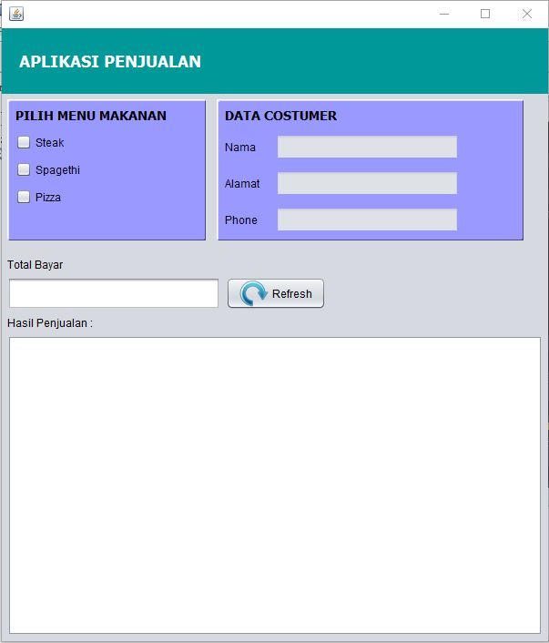

**Bila sudah di proses**

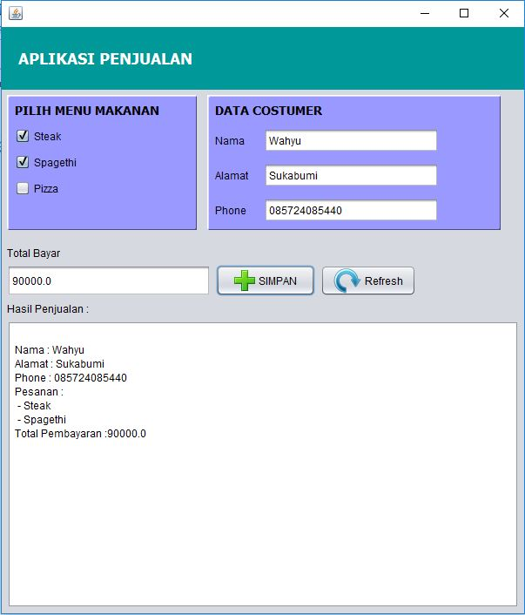

**Jika Data kostumer belum di isi**

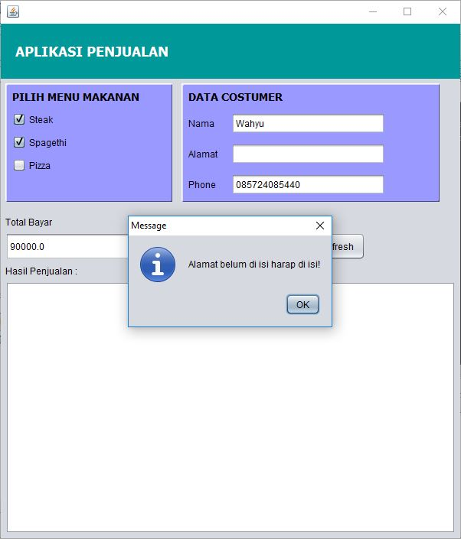

**Jika Belum memilih menu makanan**

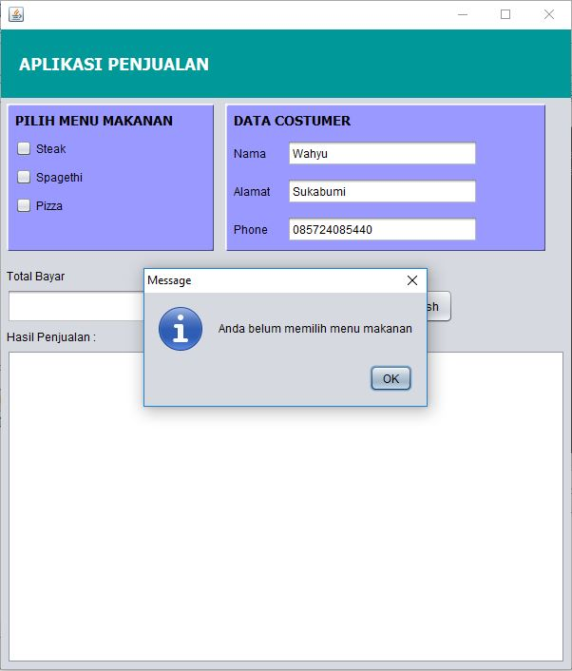

**MENAMBAHKAN SIMPAN KE FILE**

private void B_simpanActionPerformed(java.awt.event.ActionEvent evt) {

// TODO add your handling code here:

if(txtNama.getText().length()==0){

JOptionPane.showMessageDialog(this,"Nama belum di isi harap di isi!");

txtNama.requestFocus();

}

if(txtAlamat.getText().length()==0){

JOptionPane.showMessageDialog(this,"Alamat belum di isi harap di isi!");

txtAlamat.requestFocus();

}

if(txtPhone.getText().length()==0){

JOptionPane.showMessageDialog(this,"Phone belum di isi harap di isi!");

txtPhone.requestFocus();

}

if(total == 0){

JOptionPane.showMessageDialog(this,"Anda belum memilih menu makanan");

}else{

try{

String text= txtArea_Hasil.getText();

FileWriter fileWriter = new FileWriter(SimpanData);

BufferedWriter bufferedWriter = new BufferedWriter(fileWriter);

bufferedWriter.write(text, 0, text.length());

bufferedWriter.newLine();

bufferedWriter.close();

}

catch(IOException ex){

ex.printStackTrace();

}

txtArea_Hasil.append("\nNama : "+txtNama.getText() +

"\nAlamat : "+txtAlamat.getText()+

"\nPhone : "+txtPhone.getText()+

"\nPesanan :");

if(cb_steak.isSelected()){

txtArea_Hasil.append("\n - Steak");

}

if(cb_spagethi.isSelected()){

txtArea_Hasil.append("\n - Spagethi");

}

if(cb_pizza.isSelected()){

txtArea_Hasil.append("\n - Pizza");

}

txtArea_Hasil.append("\nTotal Pembayaran :"+ String.valueOf(total));

txtArea_Hasil.append("\n===========================================");

}

}

**Dan saya tambahkan library :**

import javax.swing.JOptionPane;

import java.io.BufferedWriter;

import java.io.File;

import java.io.FileWriter;

import java.io.IOException;

**Screen Shoot**

